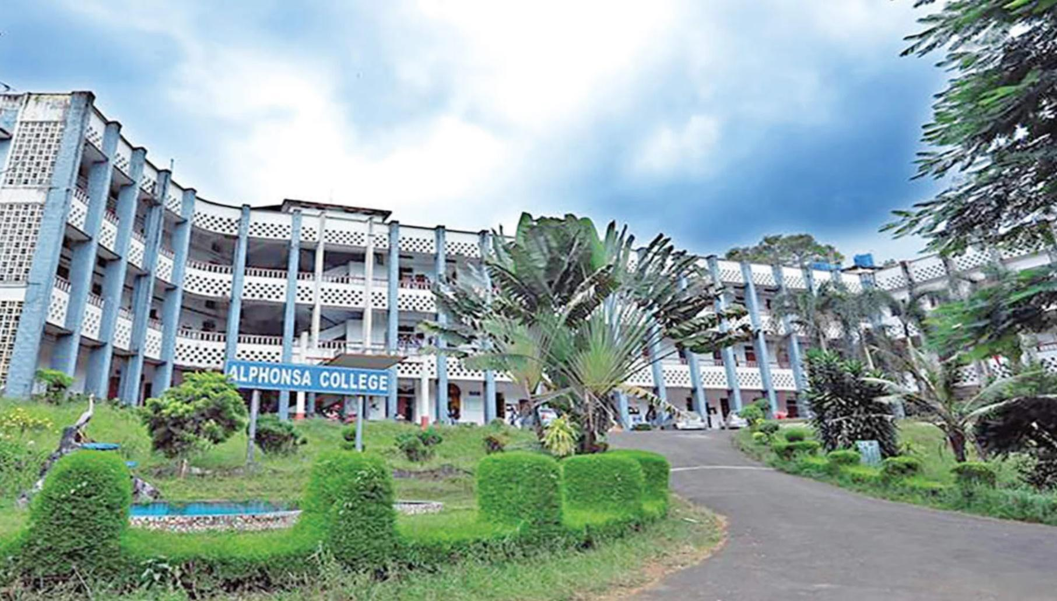

ALPHONSA COLLEGE PALA
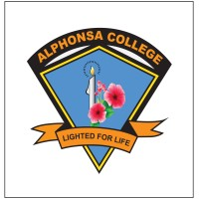

ALPHONSA ALUMNAE ASSOCIATION
DOCUMENTATION OF ACTIVITIES 2023-24

Alphonsa College has a registered Alumnae association and it is functioning effectively which provides an opportunity for former students and retired teachers to continue their bond with the college. The executive committee members met on 3 January 2024 and decided to conduct the Annual Alumnae meet on 26 January 2024.
The annual alumnae meet Alstagia 2024 was held on 26 January 2024 at the college auditorium. Rev. Dr. Shaji John, Principal of the college welcomed the gathering. Dr. B. Sandhya IPS was the chief guest and the keynote speaker. Alumnae association president, Dr. Ancy Joseph, Rtd Principal, S.D College, Kanjirappally presided over the function. The meeting honoured the former principals, 1964 predegree batch and first batch degree students, prominent alumnae from various departments and the retired teachers. To make the get together more attractive and memorable, we conducted various games and competitions. Vice principal of the college, Rev. Dr. Manju Elizabeth Kuruvila proposed the vote of thanks.
Alstagia24
alstagiaNews
alphonsa alumnae meet 2024Brochure.pdf

