ALPHONSA COLLEGE, PALA
ANNUAL REPORT OF UBA ACTIVITIES 2025-2026
AISHE Code: 11593
The Post Graduate Department of Clinical Nutrition and Dietetics in association with UBA observed Food Safety Day with the aim of creating awareness about the importance of safe and hygienic food practices. The second year students of the department conducted a skit at SH High School Bharananganam on 01/07/2025 with the aim of creating awareness about the importance of safe and hygienic food practices.
The skit highlighted everyday situations where negligence leads to food poisoning, such as consuming stale food, eating unhygienic street food, improper storage, and lack of hand washing while cooking. It also showed the severe health consequences of food poisoning, including stomach pain, vomiting, and weakness. Through a mix of humor and realistic scenes, the skit effectively conveyed how simple precautions like washing hands, cooking food thoroughly, checking expiry dates, and maintaining cleanliness can prevent such problems.
One of the student provided awareness class also in relation to food safety highlighting food safety is a shared responsibility and that awareness is the first step to prevention. The audience responded positively, acknowledging the importance of the topic.
The audience responded with great enthusiasm and appreciation. The program concluded with a pledge by students and staff to follow food safety measures in daily life and spread awareness in the community. The skit proved to be an effective way to understand the seriousness of food poisoning and the need to practice safe eating habits.
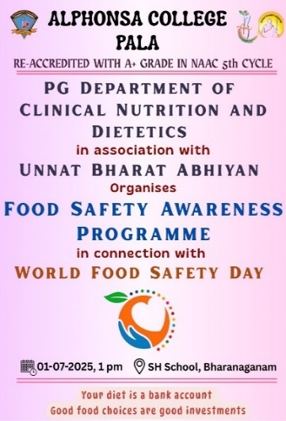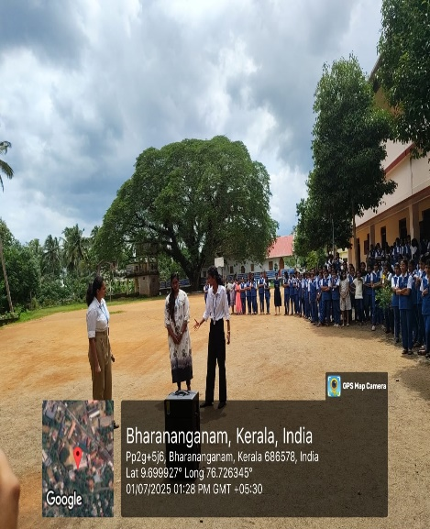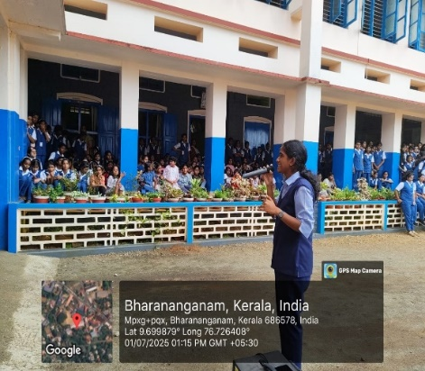
Brochure Skit performance and education
The Department of Botany, Alphonsa College, Pala, in association with Unnat Bharat Abhiyan and Biodiversity club organized an outreach programme as part of Thalir 2025 – A Green Initiative on September 18, 2025, at Government Higher Secondary School, Edakkoli. The event coincided with World Ozone Day and aimed to promote awareness about the urgent need for ozone layer protection and broader environmental conservation.
A dedicated team of 42 enthusiastic students and 3 faculty members from Alphonsa College took part in the programme, joining the school’s staff and students for the activities. This collaboration exemplified inter-institutional commitment to green initiatives and community engagement.
The main highlight of the programme was an awareness session on the importance of ozone layer protection and environmental conservation. This was followed by an environmental quiz competition for the students of the host school, which witnessed enthusiastic participation. To further reinforce the message, the students of botany department staged a skit focusing on environmental awareness, which was highly appreciated by the audience for its creativity and impact.
Prizes were distributed to the winners of the quiz competition. The programme successfully instilled a sense of responsibility among the students towards safeguarding the environment.
The event concluded with positive feedback from both institutions, strengthening the commitment to environmental sustainability and community participation.
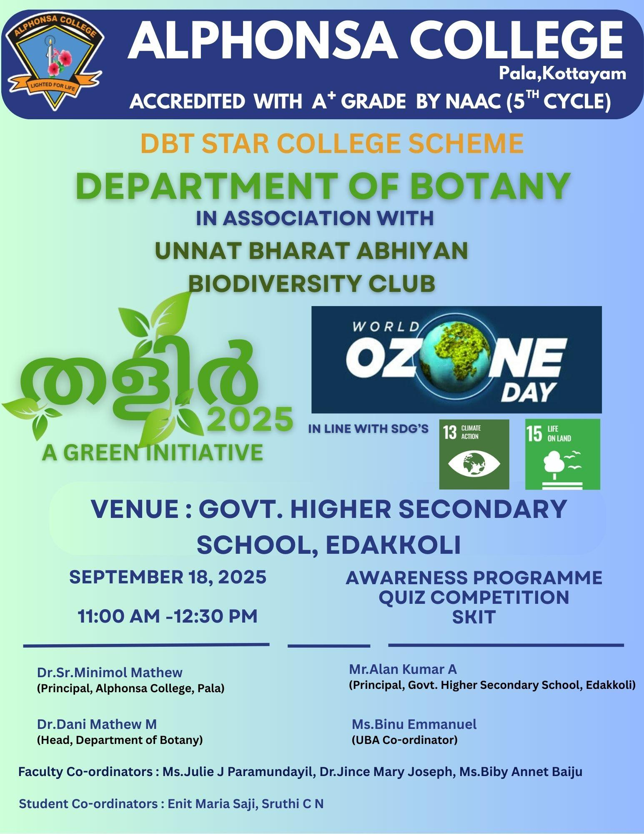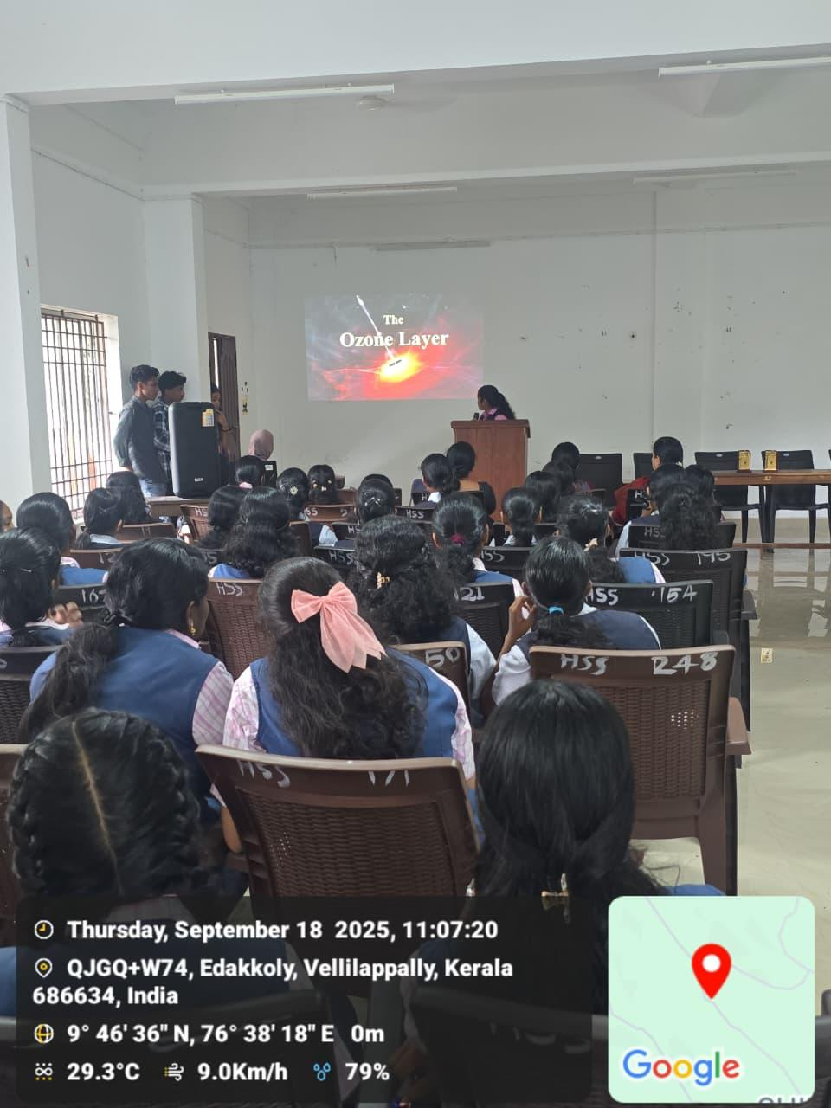
Brochure Class and Quiz

The department of Physics in in association with Unnat Bharat Abhiyan organized LED Assembly and Repair Workshops at St. Augustine’s Higher Secondary School, Ramapuram on 19.11.2025. The students of the Department of Physics were the resource persons for the skill development programme. As part of the Vocational Training and Skill Development Programme for +2 students, Maria Raju and Devika Ajay of III DC Physics took demo classes and gave hands on training to the students on LED assembly and repair. It helped the school students with the technical details involved in LED and how to repair faulty LED’s. Maria Raju and Devika Ajay also talked about the importance of Energy Conservation and how Repair, Reuse and Recycle of material is essential for the Society.
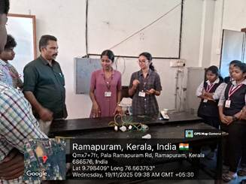
LED Assembly and Repair Workshop

The Department of Chemistry, Alphonsa College Pala, in collaboration with Unnat Bharat Abhiyan (UBA), organized a sustainability awareness program in Meenachil Part 1 and Part II, Pala, Vellappadu locality, from November 24-30, 2025. The program aimed to promote water conservation and sustainable living through an awareness campaign and distribution of informative brochures. The initiative successfully engaged participants from diverse backgrounds in village and hostel settings, simplifying sustainable practices and highlighting their practical applications. The brochure emphasized simple, everyday ways to save water, making sustainable living accessible to all. The campaign encouraged the adoption of eco-friendly habits, fostering a shift toward environmentally conscious living.

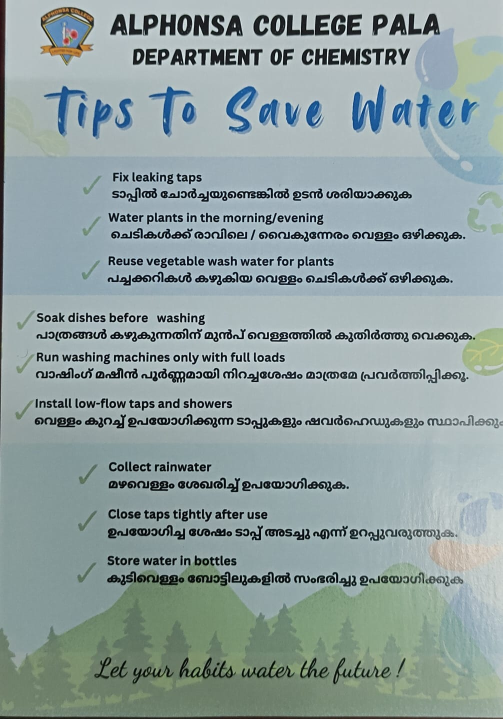
Brochure

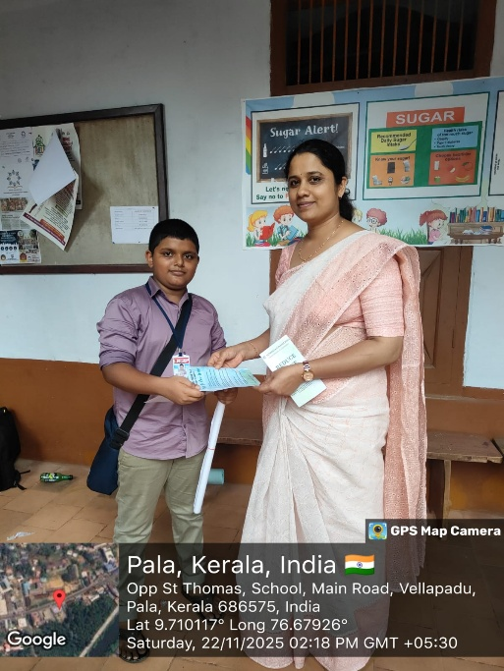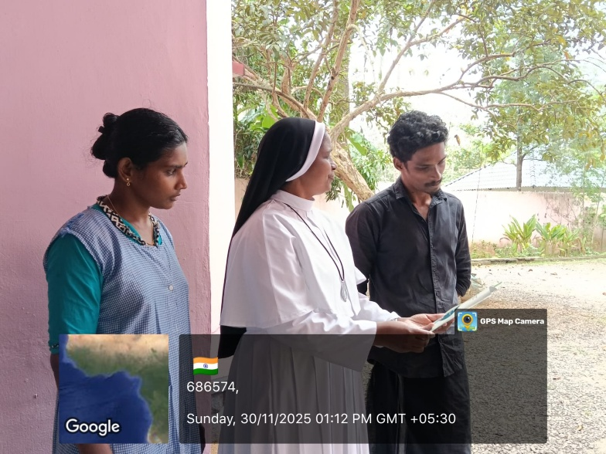
Awareness Session

The Department of Chemistry, Alphonsa College Pala, in collaboration with Unnat Bharat Abhiyan (UBA), organized a 10-day "Clean Village" awareness campaign from November 21 to 30, 2025, in Meenachil Part 1, Meenachil Part 2, Pala, Vellappadu, and Puliyannoor localities. The campaign focused on promoting cleanliness and sustainability, emphasizing the Reduce, Reuse, Recycle (3Rs) principle. Students distributed brochures and conducted awareness campaigns, engaging the public and encouraging eco-friendly habits.
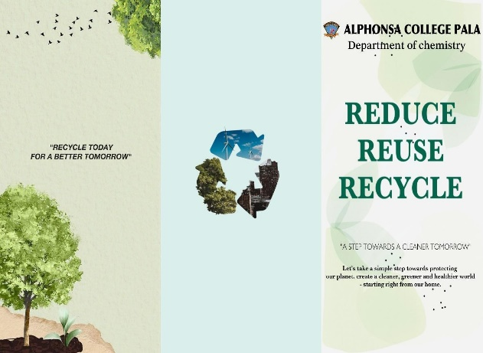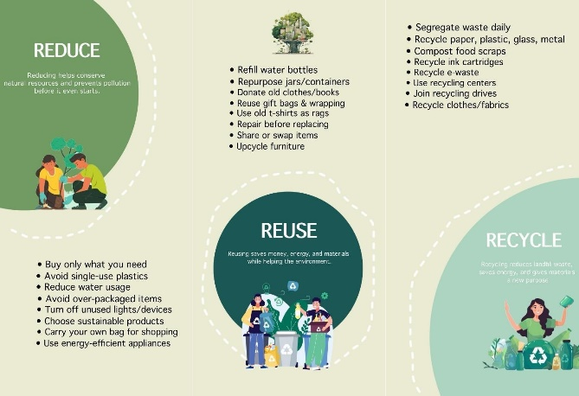
Brochure
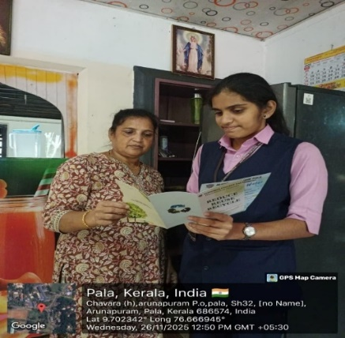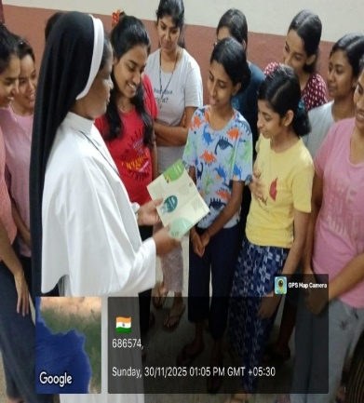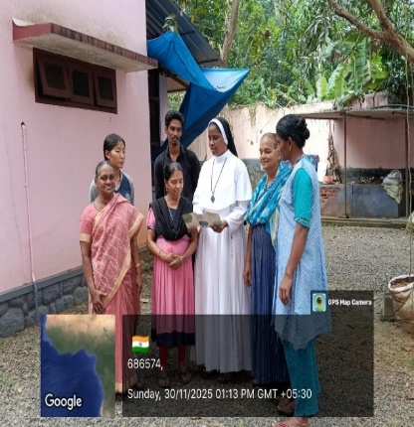
Awareness Campaigns

The Department of Chemistry, Alphonsa College Pala, and Unnat Bharat Abhiyan (UBA) organized an awareness class on 'Personal Hygiene' for +1 and +2 students at St. Anthony's Higher Secondary School, Plassanal and St Augustine's HSS Ramapuram on January 14 and January 19 respectively, 2026. More than 100 students participated in the event, gaining valuable insights on maintaining personal hygiene. The interactive class aimed to promote healthy habits among students.
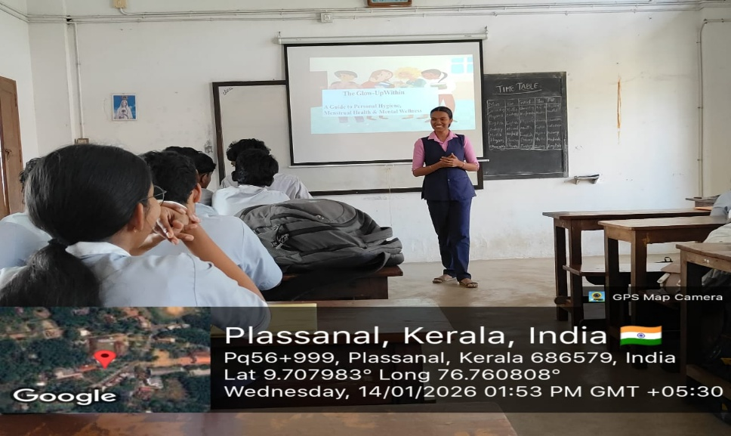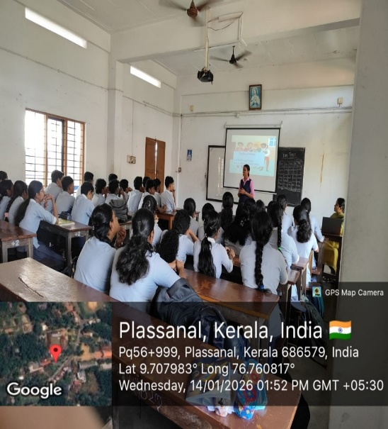
Awareness Class on 'Personal Hygiene'

The Department of Chemistry, Alphonsa College Pala, and Unnat Bharat Abhiyan (UBA) organized an awareness class on ‘Constitutional Values’ for +1 and +2 students at St Augustine's HSS Ramapuram on January 19, 2026. The session, led by Kamari Vinaya Babu (III DC Chemistry), saw 70 students participating and gaining valuable insights on Constitutional values. The interactive class aimed to promote awareness and understanding of India's Constitution among young students, focusing on the importance of democratic principles and civic responsibilities. The event provided a platform for students to engage with constitutional values and understand their role in nation-building. The session was well-received, and students appreciated the opportunity to learn about their rights and duties as citizens.

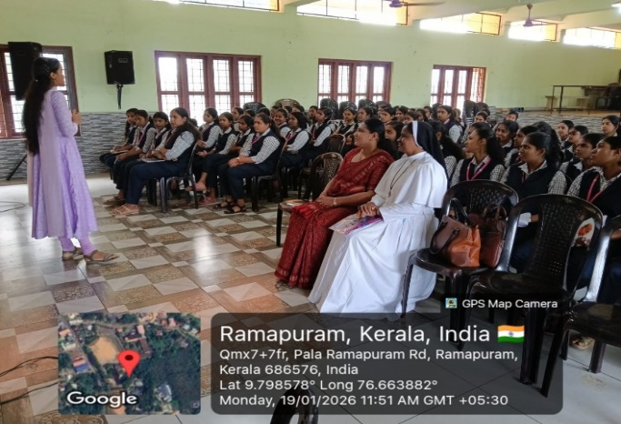
Awareness Class
Department of History in association with Unnat Bharat Abhiyan of Alphonsa College organized an awareness class on the topic ‘Water Resource Management’ at Kalanilayam UP School, Puliyannoor, Pala, on 10th December 2025. Ms. Shincy Sebastian, student of III year History was the speaker on the topic. This programme was organized as part of our ongoing efforts to promote the importance of proper water management. The class concluded with an open forum where students had the opportunity to ask questions and share their thoughts on water resource management. The interactive session facilitated a deeper understanding of the topic and clarified any doubts.

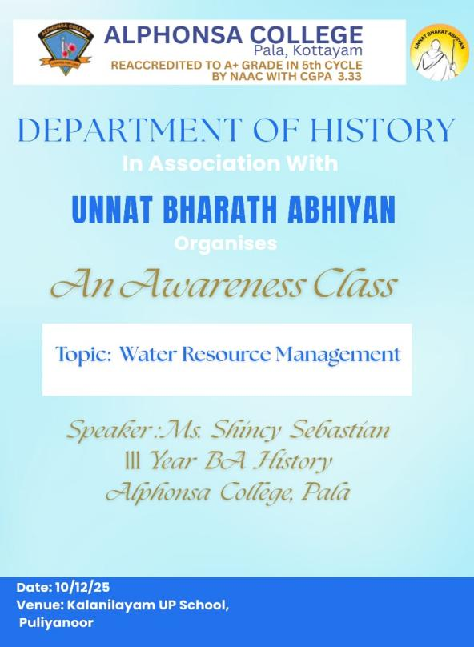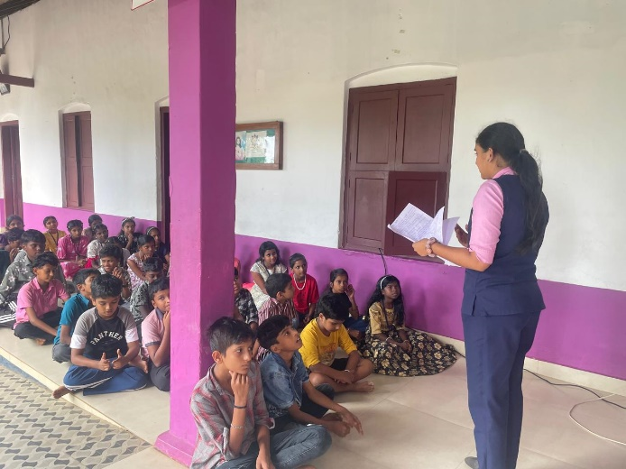
Brochure Awareness Class

The Department of Economics, Alphonsa College Pala, and Unnat Bharat Abhiyan (UBA) organized an outreach and community engagement activities in association with Unnat Bharat Abhiyan (UBA). The students of IIDC Economics organized a visit to Dhaya Bhavan Boys Town during the Christmas season. The visit aimed to spread the spirit of Christmas, foster social responsibility among students, and engage meaningfully with the inmates of the institution.
The visit was organized by the IIDC Economics students under the guidance of faculty members and in collaboration with UBA. The students were warmly received by the authorities and inmates of Dhaya Bhavan Boys Town. The festive atmosphere of Christmas added warmth and joy to the occasion. As part of the visit, the students contributed a sum of ₹3,500 to support the welfare and daily needs of the inmates. This contribution reflected the students’ commitment to social service and collective responsibility. A significant highlight of the visit was the interaction session with the inmates. The students engaged in friendly conversations, shared Christmas wishes, and spent quality time listening to the experiences and aspirations of the inmates. The interaction fostered mutual understanding and emotional bonding, making the celebration meaningful beyond material support.
The students also participated in informal activities that brought smiles and joy to the inmates, reinforcing the true spirit of Christmas—love, sharing, and togetherness.
The program aligned well with UBA’s objectives of promoting social awareness and active participation of students in nation-building activities.

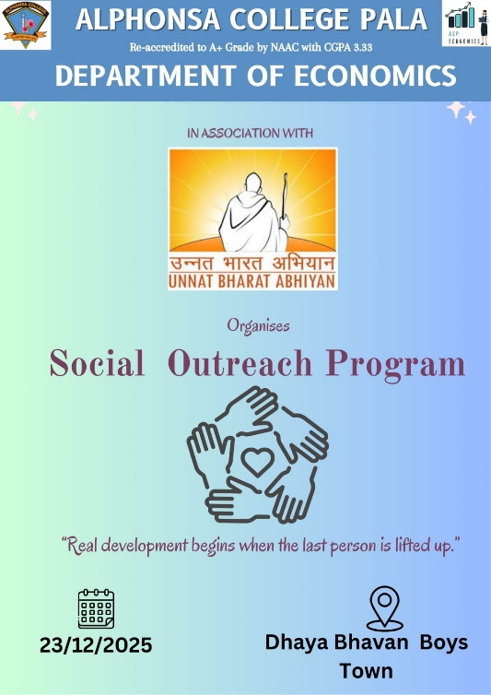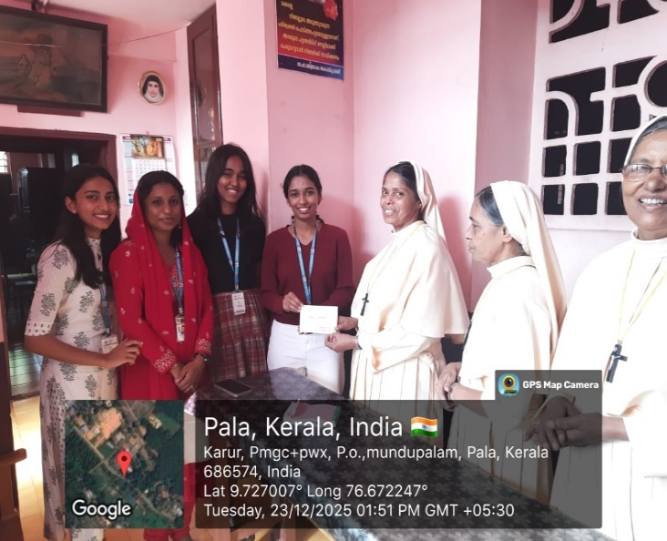
Brochure Contribution to the institution

As part of the institution’s community engagement and social responsibility initiatives, students of Department of Zoology, Alphonsa College, Pala organized a menstrual hygiene awareness programme for high school students of St. Sebastian’s H.S.S.S., Kadanadu on 25 February 2026. 34 students participated in the programme. The programme was conducted with the objective of promoting awareness about menstrual health and encouraging healthy hygiene practices among adolescent students.
During the session, the student volunteers provided information on menstrual hygiene management, emphasizing the importance of proper sanitary practices, safe use and disposal of sanitary products, and maintaining personal health and well-being during the menstrual cycle. The programme also addressed the social misconceptions and stigma associated with menstruation, encouraging students to view menstrual health as a natural and important aspect of overall health
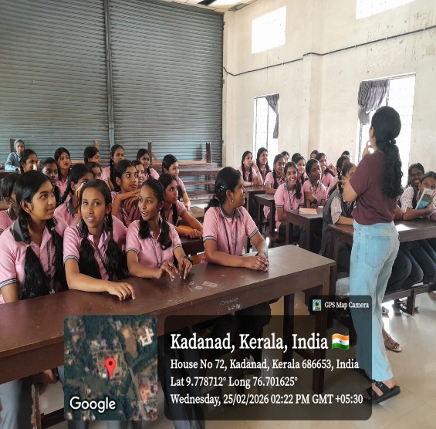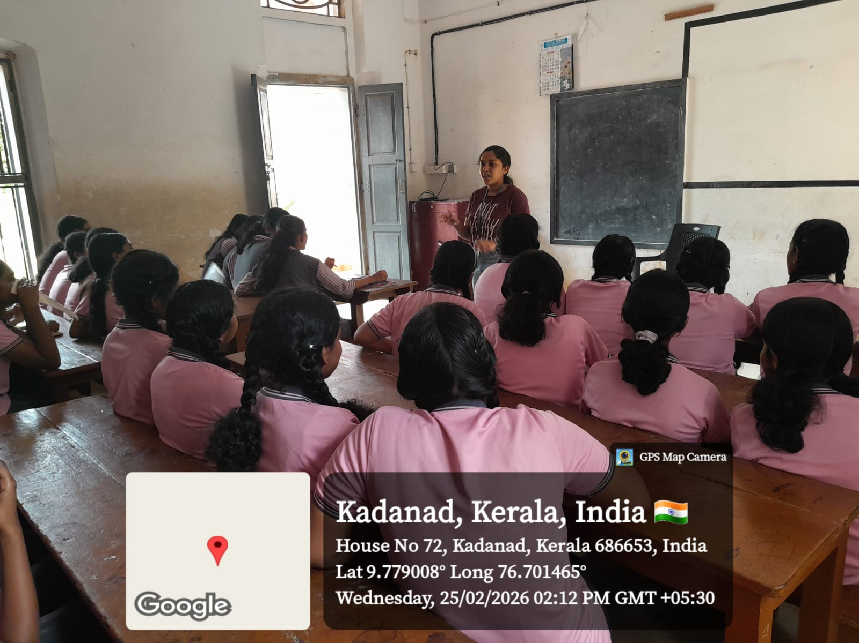
Awareness Class
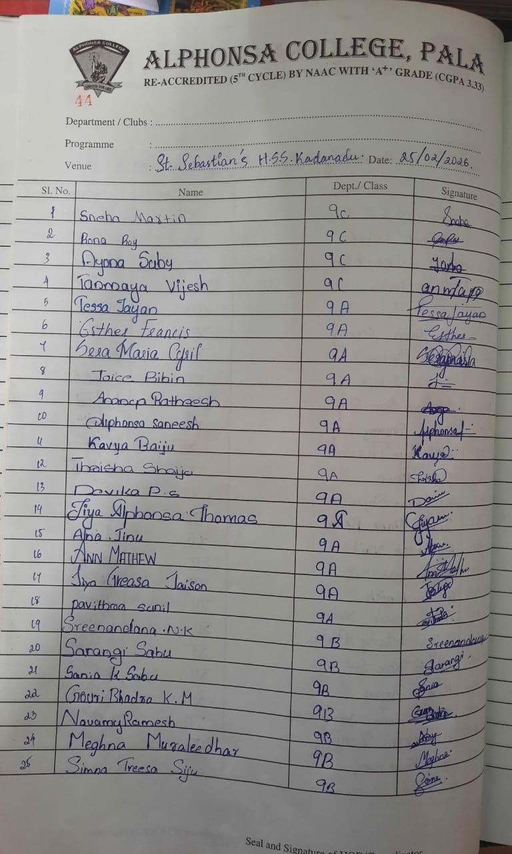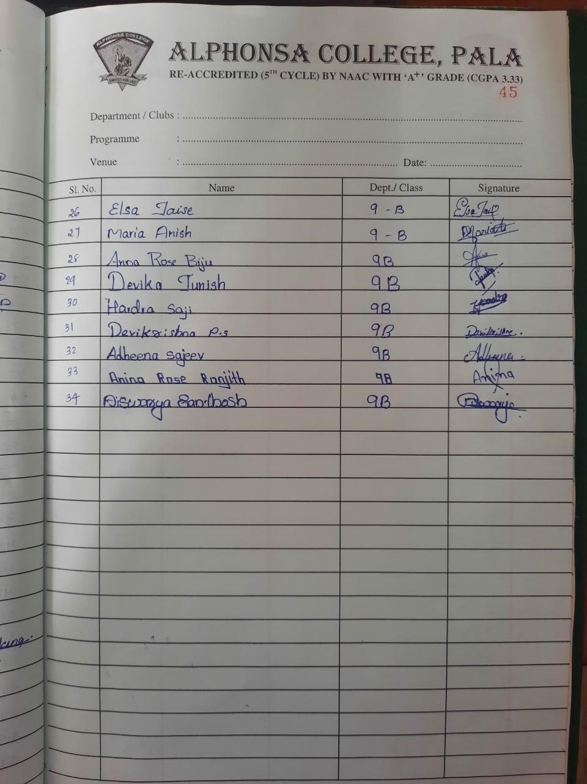
Participant’s List
Students of Dept. of Zoology Alphonsa College, Pala conducted a menstrual hygiene awareness class for higher secondary students at Vilakkumadam, Paika on December 31, 2025, as part of their community outreach and health awareness initiatives. The programme aimed to educate adolescent students about the importance of menstrual hygiene, proper sanitary practices, and the need to overcome social stigma associated with menstruation. During the session, the students explained various aspects of menstrual health, including hygiene practices, use and disposal of sanitary products, and the importance of maintaining physical and mental well-being during the menstrual cycle. The session was interactive, allowing the participants to ask questions and clarify their doubts. The programme helped create awareness, encouraged open discussion on menstrual health, and promoted healthy hygiene practices among the students.

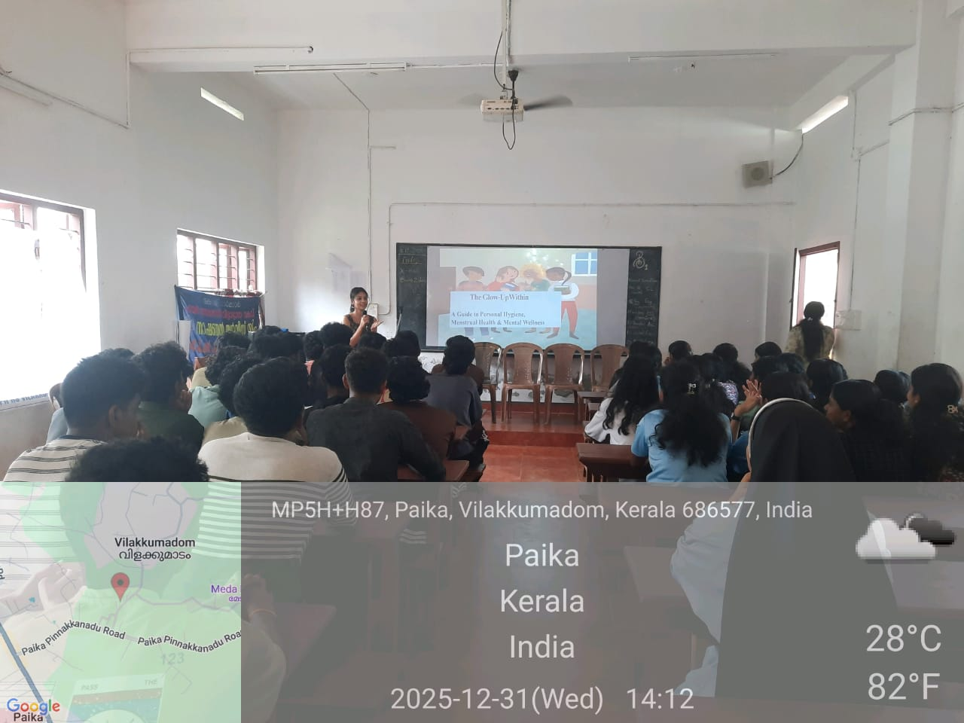
Awareness Class

As part of the Unnat Bharat Abhiyan (UBA) initiative, efforts were made to extend educational opportunities and environmental awareness to students from rural communities. Under this programme, students from the adopted village school, St. Joseph’s High School, Mutholy, were invited to participate in the biodiversity workshop titled “Traditional Knowledge for a Sustainable Future,” conducted at Alphonsa College, Pala on 13 February 2026. Ten students from 8th and 9th standard were participated.
The workshop provided the rural students with an opportunity to gain exposure to topics related to biodiversity conservation, indigenous knowledge systems, and sustainable environmental practices. Through expert lectures, interactive discussions, and learning activities, the participants were able to enhance their understanding of the importance of traditional ecological knowledge and biodiversity protection. The initiative helped promote scientific awareness, environmental responsibility, and inclusive learning among rural students.
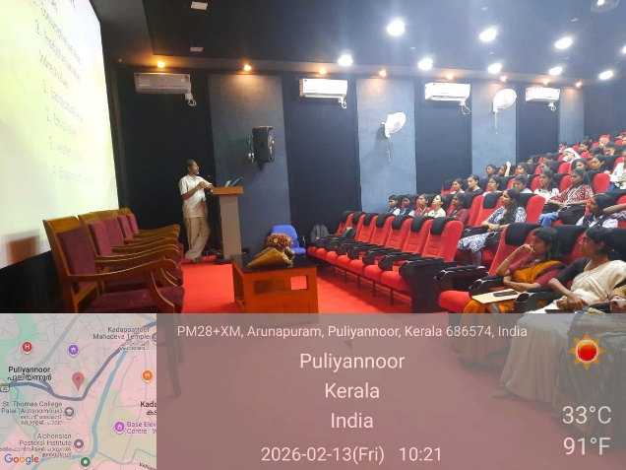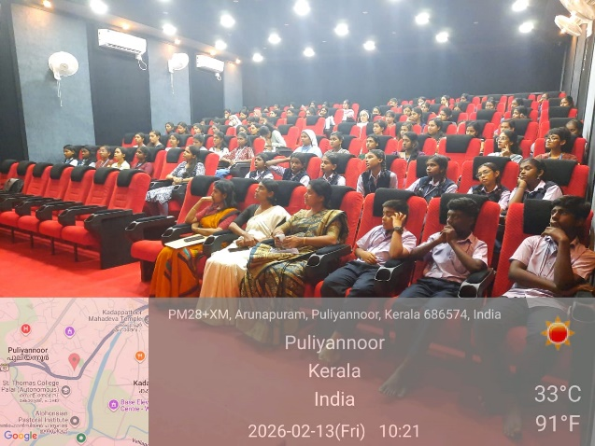
Awareness Class

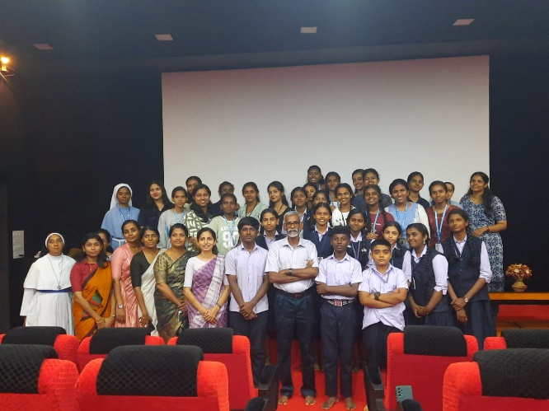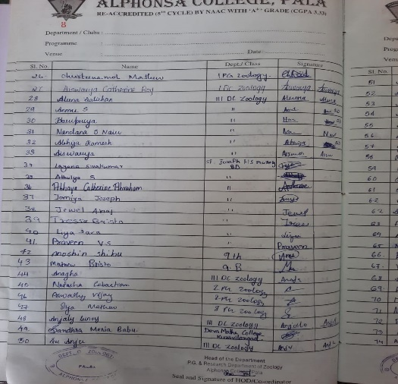
Participant’s List

